**Succumbing**

**to the**

**CALL**

**Overview - Pitch**

Succumbing to the CALL is a single player/co-op top down 2D adventure RPG with classic hack and slash elements and some mild horror integrated. The fun consists on following the character on his road to survive the turmoil of the land and defeat god or return home. The land is plagued by an unknown disease that infests everything around. Pursue the end of the journey and find the path for Tac and, maybe, for his childhood friend Pene.

The player is pushed in Ephemera, a world full of magic, action and peril while fighting unknown creatures and wielding weapons of immense power. You will get to uncover your extraordinary potential through battles with beings of another world through this atmospheric rich ever-changing free-roam game.

This PC game is a hack and slash focused on fighting smart instead of head bashing into groups of enemies. Inspired by Darkwood but meant for a lighter atmosphere.

**Look and feel**

The player has a top down view of the screen slightly from behind the character. The 3D animation completes the enjoyable experience the game has to offer. The player can roam a world of tall trees infected by the plague and broken houses and experience the savageness of what has become of Ephemera.

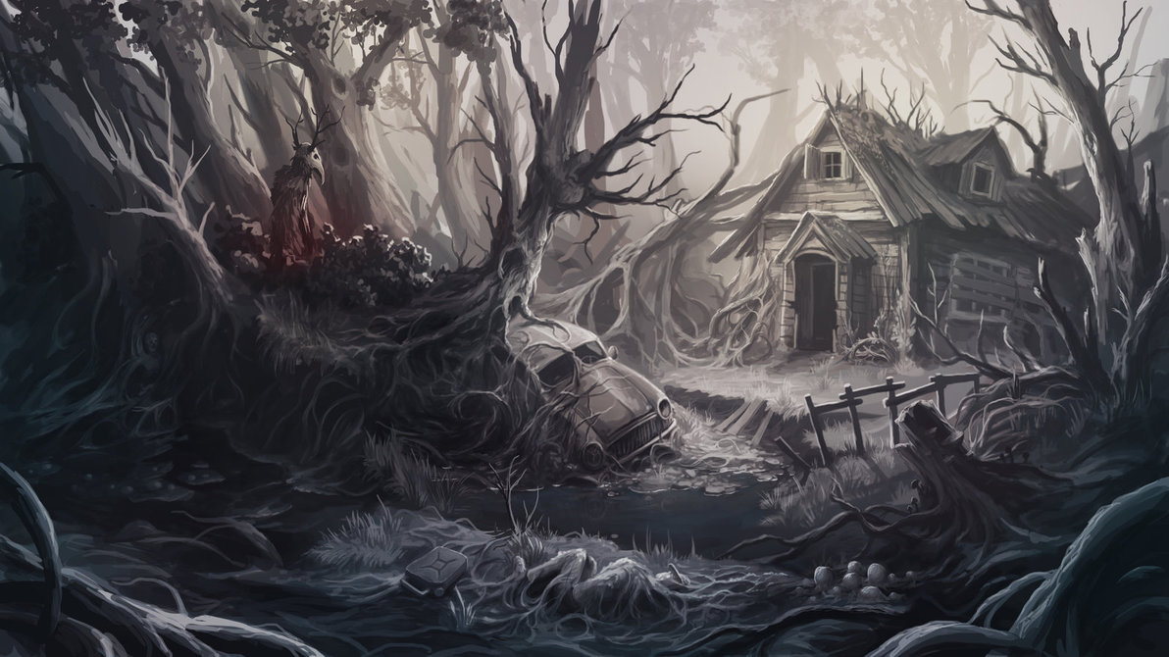

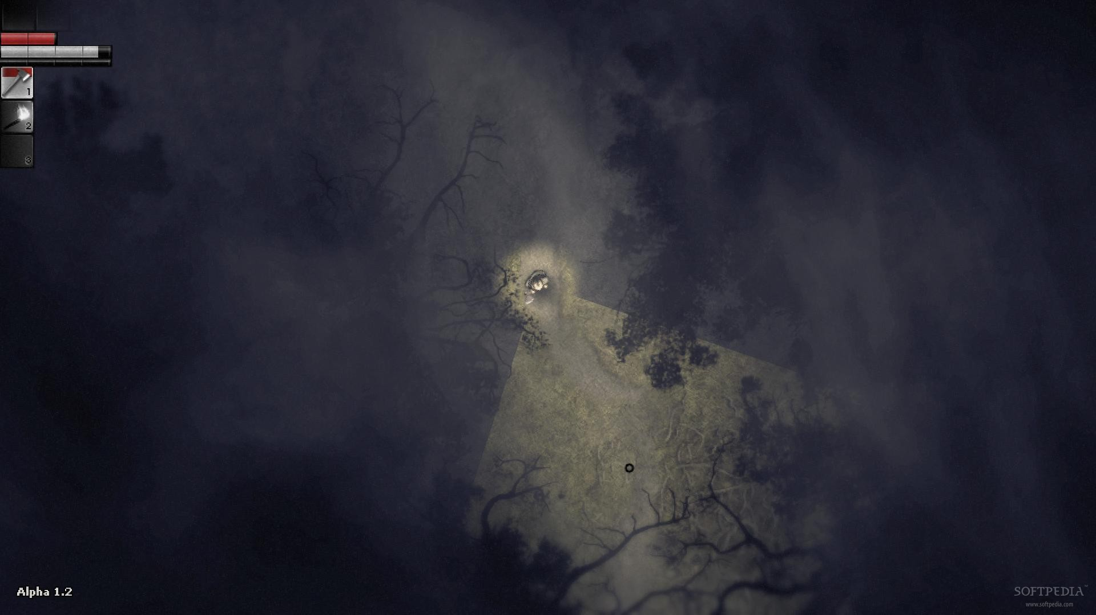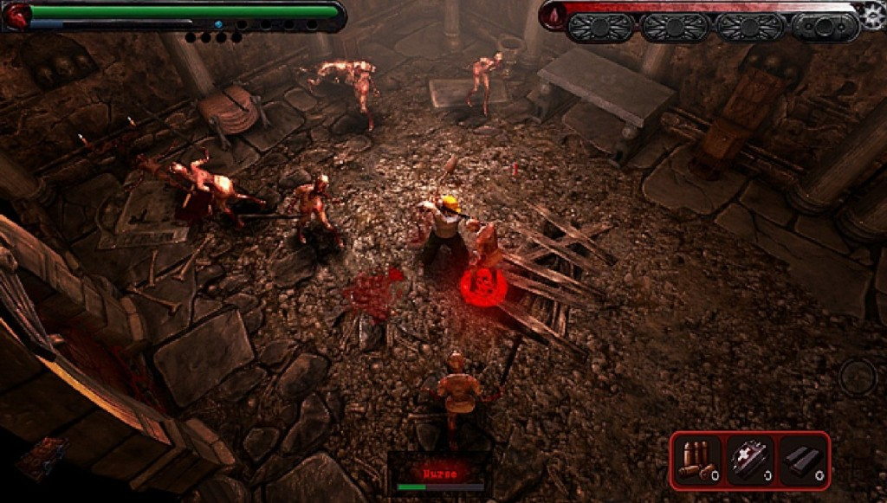What the player sees is a combination of Darkwood and Zelda, enhanced by a transistor narrative, coming from GOD, one of the deities of the world.

The player is placed in an enchanted world where he has the opportunity to witness how evil corrupts and spreads. In this world of magic, new races can be met, and new love stories can develop. Beware of the plagued enemies, as their fangs are sharp, and their chase is relentless.

Sound effects take the player in a world of mystery and dread as the repetitive gloomy instrumental music, accompanied by the growls of monsters picture the suffering of the land and its inhabitants. A good song would be "Cold" by Jorge Méndez or Orchestra Diabolica - House of Cacophonous Shadows.

**Story**

**Backstory:** The world where the main character is transported, Ephemera, is a world of magic and unknown creatures, a beautiful world where gods roam the earth. One day a plague starts to spread upon this beautiful land, a plague that the inhabitants can’t fight against. This plague starts spreading around the time Tac’s mother gets sick. Ella, once the most powerful god of this world, has thrown away her status to ascend to a higher plane. When Ephemera gets sick, so does she, since she is connected to the world.

Tac, the main character: His mother, Ella, has always told Tac stories about beings from a different place (Where he is now being populated by only humans). The more he grew, the less he believed. She has told him not to doubt, as he might one day see. When his mother falls sick, he feels a tremble in his heart. When she dies, he is devastated, and remembers the times they were together.

**Story:** He is going through the forest to search for butterflies. He is doing it in honor of his promise to her made in childhood to catch a blue monarch butterfly when they were both playing in the nearby forest. His brother is Pene if in co-op, and they both go together. Story progresses for both the same. He keeps going deeper into the forest, chasing the butterfly. He also feels attraction to where the butterfly is leading. When he notices he has wondered too far off, it’s already too late.

Tac unknowingly enters this world, lured by Omphal, and is slowly getting recognized by it. Overseer presents himself as GOD and asks Tac to cure the world that his mother has lorded over for so long. Along the way he uncovers more and more of the story. He finds a trail to the cave Em Evas is in. He can follow the trail to find her, still conscient, but plagued. (Triggers side quest) When the Treefather dies, Omphal shows herself again, in the butterfly form, and asks him to go to a hidden spot, where GOD has no power. If Tac decides to do that, he can find pieces of the truth about this world. (He still follows GOD but ending differs)

When he enters the village, he follows GOD’s commands to release the seals on the Pillars of Mold and then enter the sealed Mayor’s manor. There he finds Naya. (Triggers side quest). After he defeats the Mayor, he closes the portal to where the gloom was coming from. The story ends here if Tac didn`t go to the hidden spot described by the butterfly after the Treefather dies (He still goes to cave, but to be teleported back home). If he followed the instructions set by the butterfly, he asks GOD to meet him, to ask for one of his wishes to be fulfilled. GOD considers for a bit and leads him to the cave, telling him there will be more dangers inside, until he reaches him. He finds the capture Omphal. He challenges GOD, they then fight, and Tac becomes the new ruler of this world. (This could be considered Campbell’s paradigm of the monomyth)

**Secondary characters:** Em Evas is the elf girl that lives in the house at the edge of the village. She is a botanist and an alchemist. She often goes into the woods to look for herbs. When the plague has started to spread, she has tried to study it and find some way to reverse it. One day, when she was wondering the woods, she got attacked by the mutated animals. When she tried to escape she stumbled inside a cave. There she got infected by the plague.

Omphal is the butterfly that Tac follows in the forest. She is a god of Ephemera, locked away by Overseer. She has tried to stop the plague but was caught by Overseer in the process. She knows Ella, and that she has a son, so she tries to get him to save this world.

Overseer, also known as GOD to Tac, is the one that has filtered the plague in this land. He is one of the more powerful gods of Ephemera. He tries to gain control of it by slaying the ruler of this world, Ella.

The Treefather, once a peaceful keeper of the forest, now corrupted by the plague, tries to stop Tac from going forward. Father of Omphal. He is a god of serenity and good will, with his only wish to make the forest a peaceful place for everyone.

The Mayor, the reason for the plague. He finds a mystic book, he follows the incantation and releases the powers inside. He is guided by Overseer.

Naya, the mage, is sent here to figure out what this plague is about and a way to stop it. She follows the lead to the Mayor’s house and there she gets trapped.

**Interface**

The screen would have only the player and the surroundings. The camera is character locked, even though the player can expand the radius with in-game abilities. There wouldn`t be any secondary objects on the screen aside from a health bar, a mana bar (or energy bar) on the top left corner; and a settings button on the top right.



Controller diagram: - W A S D movement

* Q/Left Click – attack (orange
* )
* Hold Q/Hold Left Click – charge attack (orange)
* E/Right Click – dodge (yellow)
* 1,2,3,4,5,6,7 – spell binds (green)
* I – inventory (blue)
* F, G – quick slot 1 and 2 (For potions) (brown)
* Esc – menu (black)
* Tab – quest menu (purple)
* M – map (grey)
* 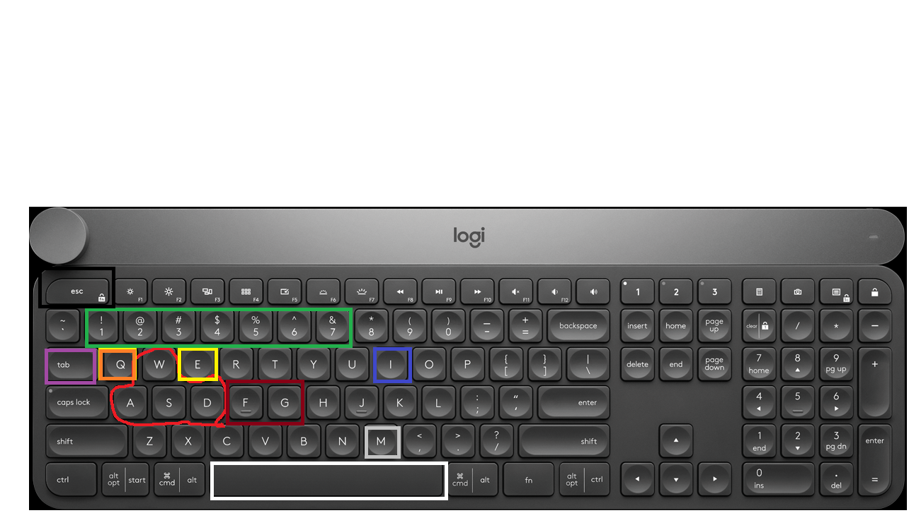Spacebar – interact (white)

**Start-up**

The player can advance forward on the dusty road, even though there are openings in the forest where there are groups of enemies. If player goes according to plan, he should face a lone wolf and hopefully win. If he roams in the forest, he should first face a couple of wolves, who alert a few more enemies.

(Tutorial is in the beginning in his memories with his mother)

**Objectives**

Main objective (A few secondary steps are missing on each of those): - slay the 3 dryads -> search the caves for the Ancient Script -> defeat the Treefather -> discover the Slaughterhouse and slay the Chief -> get the keys to the Mayor’s manor -> crash the 6 orbs -> defeat the Mayor -> defeat the Cave Guard -> go home OR fight GOD (based on quest of Omphal) splits in 2: Win against GOD.

There are multiple endings based on the in-game relationship with other characters and decisions made during certain moments. If you defeat GOD, you become supreme god of this world. If you lose to GOD, you get killed together with the other girls and Overseer takes control of this world. If you don`t face god, you go home alone or bring the girls with you based on individual affection level. The only way to lose is to die to GOD, all other endings are good endings.

Secondary quests: All girls (Including shopkeeper – she is a girl); a few town villagers found in forest or village

**Tokens**

A. Quest NPCs: Omphal, Overseer, Naya, Em Evas, Shopkeeper, elves in town, other gods

B. Enemies: trees (static, un-killable); infested animals: bears, wolves, stags, snakes, birds; humanoid hybrids(corrupted): minotaurs, harpies, centaurs, ogres; mythical: dragons, phoenixes, unicorns

B.1. Bosses: Treefather, the Mayor, Overseer

C. Spells: Class spells, neutral spells, utility spells

D. Items: heavy armor, light armor, cloth armor, magic armor, single handed swords, dual handed swords, daggers, axes, maces, bows, (magic) staffs, trinkets: rings, necklaces, miscellaneous (these are just classes – each armor, weapon and trinket have different looks and stats depending on material and rarity), mana, health and stat pots and books, drop or collectible items: plants, pelts, meat, scales, eyes, edibles etc.

E. Structures: shop – set location in all areas;

in village: houses, wells, barns, ruins

in forest: underground caves, big tree roots

**Rules**

1. Monsters react to sounds
2. Player requires health and mana potions to regenerate
3. Health reaches 0 player/enemies die
4. Player respawns on death to nearest checkpoint
5. Experience and items (from last checkpoint) are lost on death
6. Monsters evolve together with player (ex: player gets 5% hp at level up monsters get from 1% to 3% depending on type)
7. Monsters drop crafting items
8. Player learns new skills on level up
9. Items increase stat dmg (ex: player has 5 strength – sword gives 20% => player does 7 dmg)
10. Monsters give less ex the higher the player`s level is
11. Player can sell items (aside from key items)
12. Shop sells better items at a big price
13. ALL enemies have a set number of attacks
14. Stat potions improve stats temporary
15. Stat books improve stats permanently
16. Stat books and treasure items are defended by semi-bosses
17. New area unlocks after main quest in actual area is done
18. Enemies regenerate health over time after leaving combat
19. Better items drop at later stages
20. Monsters damage player with attacks
21. Player damages monsters with attacks
22. Dodge protects player from monster damage
23. Dodge partially protects monster from player damage
24. Quests are regularly given for monster slaying
25. Quests give rewards based on difficulty
26. At level up the player gets one ability point
27. Some items are level bound

**Features**

**1.**Players must decide on enemies to fight as groups of enemies are powerful and hard to deal with. R1+R4

2.Players needs to decide between taking utility skills and going to shop. R8+R7+R12

3.Players can risk getting better items and stat books. R14+R15+R1

4.Players should deal with low hp enemies first. R18+R2

5.Players should farm mobs only for a limited time. R10+R6+R19+R27

6.Players must know when to back from fights as enemies don’t lose level. R3+R5+R6

**Gameplay**

Players can have different builds, depending on class and skill trees, and complete the game multiple times in many ways. [F2+F3] Players can be punished as they can get out-level by enemies and must try harder to complete the game. [F1+F6+F3] Lowering experience gain from a certain moment onwards and giving stat increase to monsters is a stimulant to make players to keep advancing without becoming overpowered. [F5+R6] Since the game is free roam, the player can do quests in whichever order he desires as long as quests are not time bound and location bound. There is also an ironman mode where there is no checkpoint and the player has to complete all the map without dying.

Sample decision tree

Sample payoff grid:

|  |  |  |  |  |
| --- | --- | --- | --- | --- |
| Combat | | Player | | |
| Attack | Dodge | Legendary Slash |
| Wolf | Attack | 3/4 | 0/0 | 3/10 |
| Dodge | 0/1 | 0/0 | 0/3 |

**60 seconds of gameplay**

Well … there goes 1/2 of my HP … from a tree … who made this stupid map. This road looks interesting. “The hidden path leads to treasure … but beware, as there lay also hidden dangers” (GOD). Time to use a health pot I guess. Only 3 left. Maybe I should save in a bit. A couple of usual stags. Let’s face them and see if I can win without taking damage. There goes charge 1. And charge 2. Flaming Slash. One almost dead. Trample dodged. Horn smash dodged. Blade wave in front. Only one left. Normal attacks should do it. Quick loot. Ok then moving on. OH! That bear looks interesting! It got bile flowing down it’s 2 heads… CHARGE! Using Flaming Slash seems to do a lot of damage … too bad the cooldown is so big. Dodging his bite. Switching to Fury passive. Probably should have done that first. There should be a swipe next. Time to back off a bit. Spit?? The normal mob doesn’t have that! Health pot fast. Time to use the Strength pot. Slashing him did a bit of damage. He still got half HP. Violence Features should get him a bit closer to death. Flaming Slash is up. It’s prepping its bite now for sure. Time to dodge. *Roar*. Just as expected. Woah there wolf you were not invited. Should activate sonar fast for security. Flaming Slash the bear should finish him off. SO CLOSE! Oh no there comes the swipe. Heal fast! A few more hits and done.” As always the rash type I see”. Now for the wolf. Quick roll. Now a few slashes should get him. <Level up> I can get that new Heaven Strike. Now let’s see what the bear was hiding. Rare Magnite Plates. Sweet! I can make a new set of armor with the ones I have left. Also a few herbs. Let’s check the wolf first and then craft the wind glides. *HUEE* NO YOU DON’T TREE! Quick roll. HAHA! *HUEE* Slap! <You have died! > Why were you even THERE! “Remember I warned you about hidden dangers? HEHE” YOU MOTHER …..!!

**Level design**

After the tutorial, the player is faced with a choice of class. Afterwards the player is given a bump by GOD with a line such as “Not bad … now let’s go save this land”. The player is expected to check his class info and decide on an ability to level up.

The first map, the forest, is the introductory level where the story unravels itself. It is meant to make the player understand what is happening through the help of GOD. The area looks like a dark-purple forest. The enemies are randomly spawned on layers of power, sometimes randomly spawning in different zones. Shop is randomly placed somewhere before the last layer of enemies. The boss is standing right at the entrance at the village. This map should take 2 hours to pass while doing all the objectives.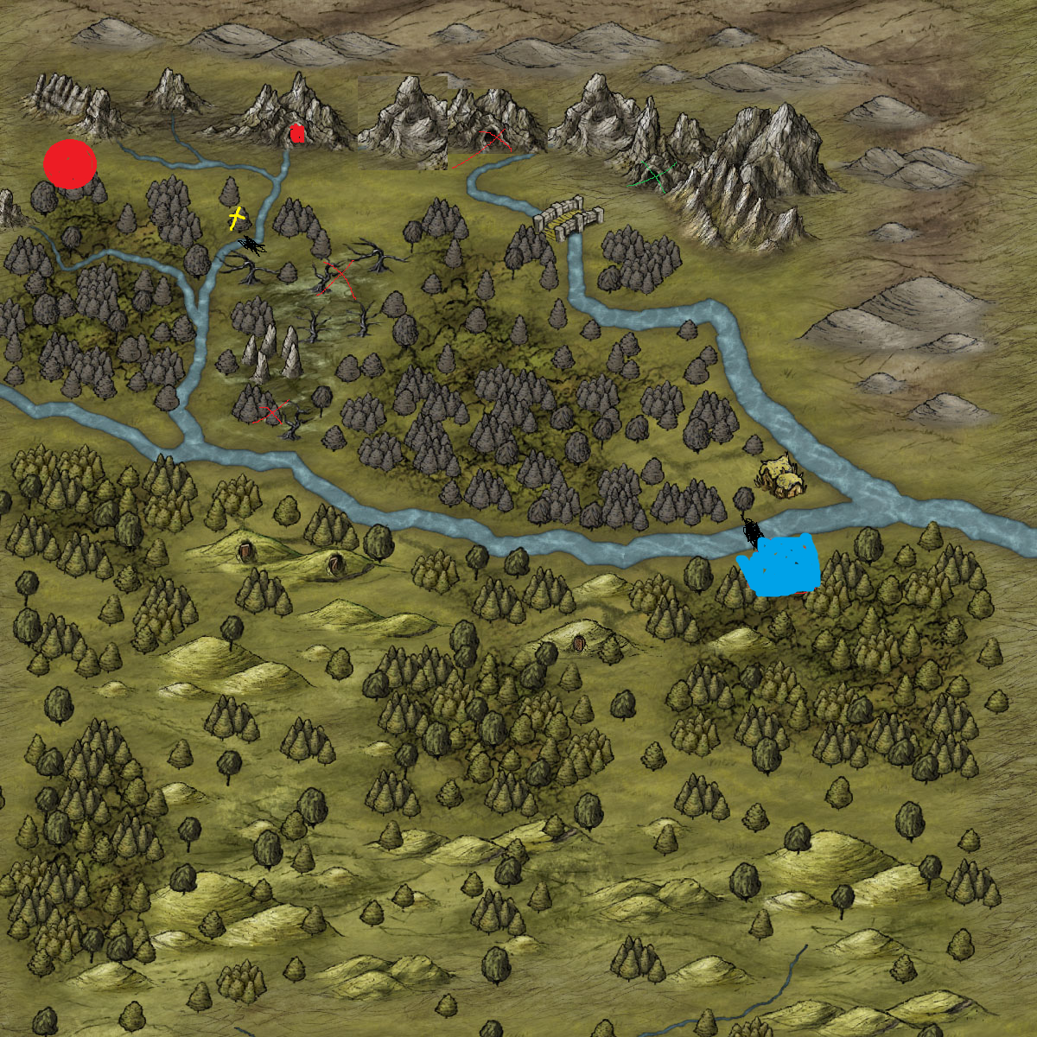

Blue is the entry point, Green X is Em Eras, red X are the dryads, circled red X is the Ancient Script, red dot is the Threefather. Yellow is the shop. Map size should be medium.

The town is the second zone. It should be made of broken houses with different pulsing protrusions coming out of them. The enemies should spawn in waves as well. The mayor house should be the inside of a moving thing. The enemies in this zone have no spawn restriction, aside from horde spawning. The duration of this map should be 2 hours.

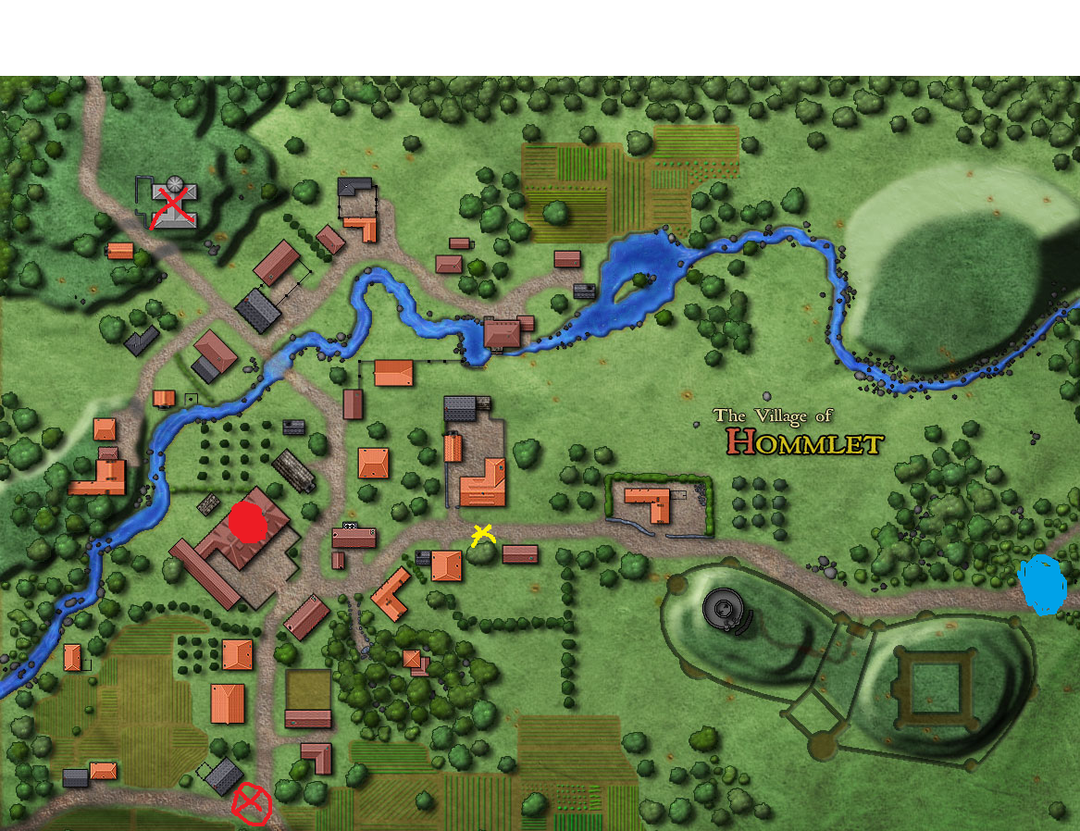

Blue is where the player comes in, yellow X is where the shop is, red X is where the Butcher is, red dot is the Mayor house, circled X is the guard to the cave.

The cave is the third zone. Here the player has only a limited number of paths. The enemies spawn on layers. The time to reach god should be around 1 hour.

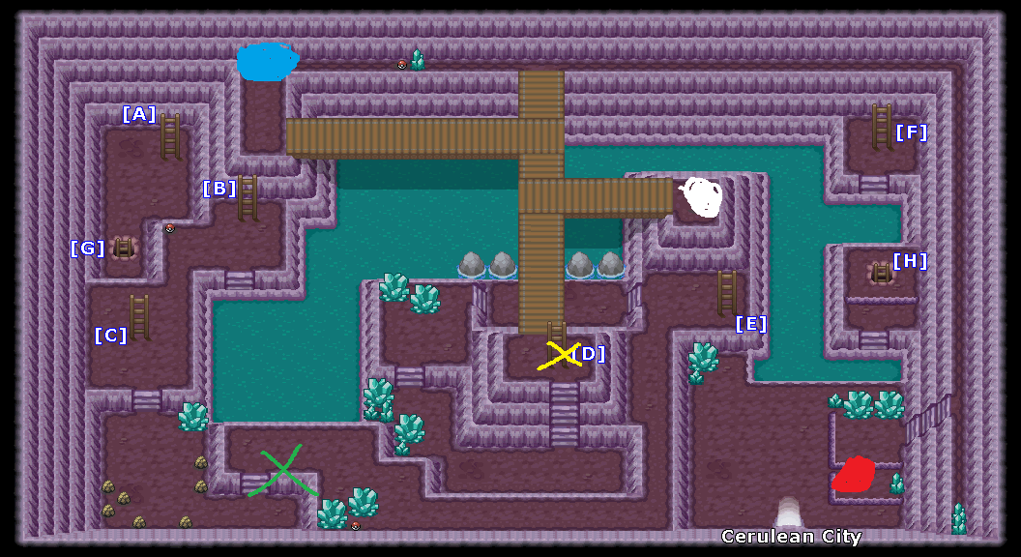

Blue is where the player spawns. Green is Omphal, yellow is the shop, red is GOD, white is the portal that leads home.

**Technical requirements**

Minimum requirements:

OS: Windows 7 32-bit.

Processor: Intel Core 2 Duo 2.8Ghz or equivalent

Video card: GeForce 8800GT / ATI Radeon HD 4850.

Storage: 5 GB available space

RAM: 4GB

Recommended requirements:

CPU: Intel i3

CPU SPEED: Info

RAM: 8 GB

OS: Windows 10 64-bit

Video card: GeForce GTX 760

Free disk space: 5 GB available space